Sampling Distributions for Sample Proportions

|  |  |  |
| --- | --- | --- |
|  | One Sample | Two Samples |
| Parameter |  |  |
| Statistic |  |  |
| Mean of Sampling Distribution |  |  |
| Standard Deviation of Sampling Distribution |  |  |
| What condition must be met to use the standard deviation formula? |  |  |
| When is the sampling distribution  approximately normal? |  |  |
| z-score formula |  |  |

Sampling Distributions for Sample Means

|  |  |  |
| --- | --- | --- |
|  | One Sample | Two Samples |
| Parameter |  |  |
| Statistic |  |  |
| Mean of Sampling Distribution |  |  |
| Standard Deviation of Sampling Distribution |  |  |
| What condition must be met to use the standard deviation formula? |  |  |
| When is the sampling distribution  approximately normal? |  |  |
| z-score formula |  |  |

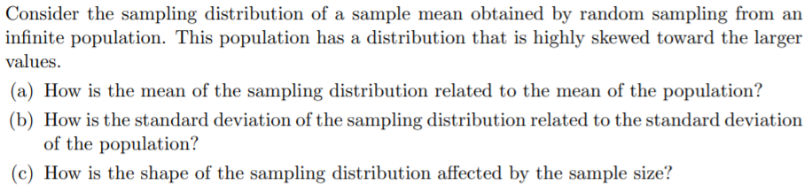1.

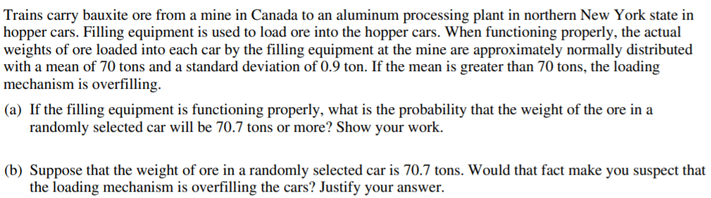

2.

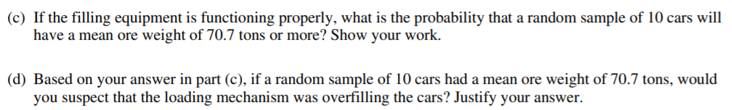

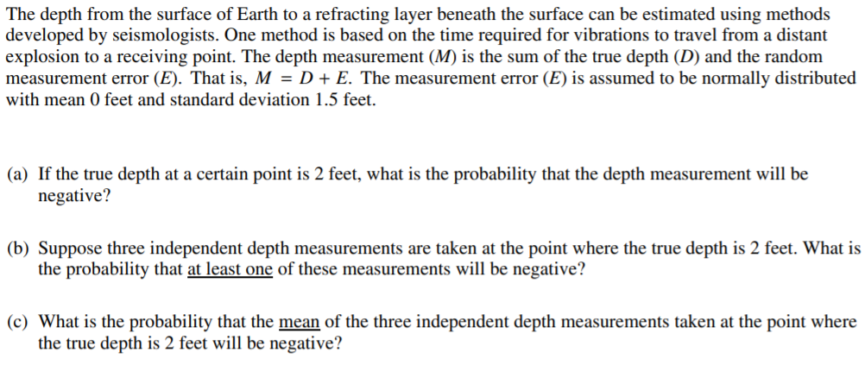3.

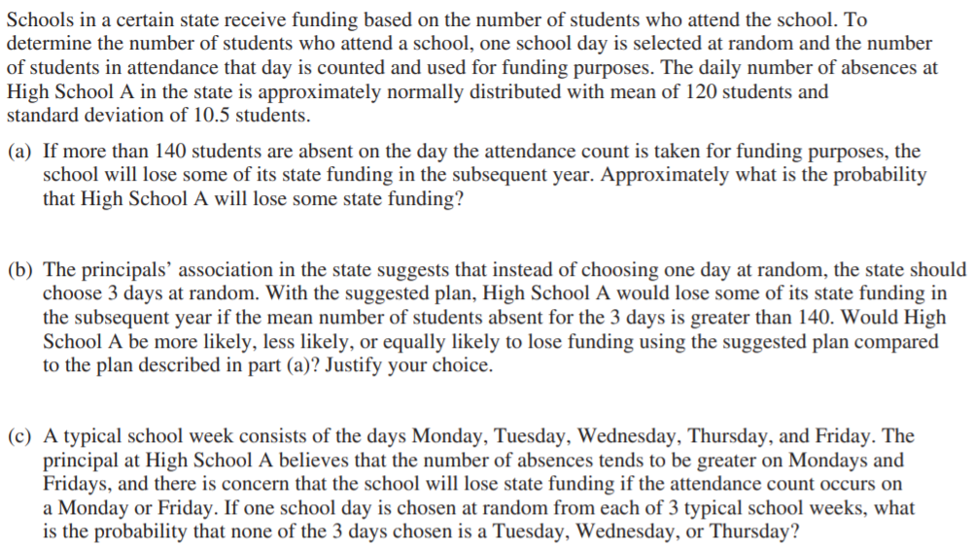

4.

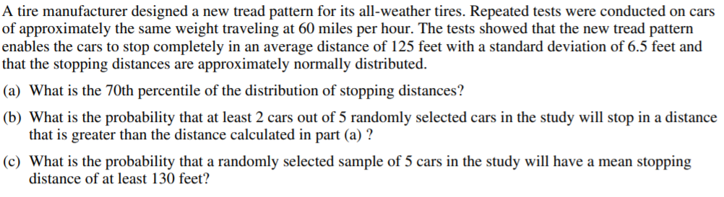5.

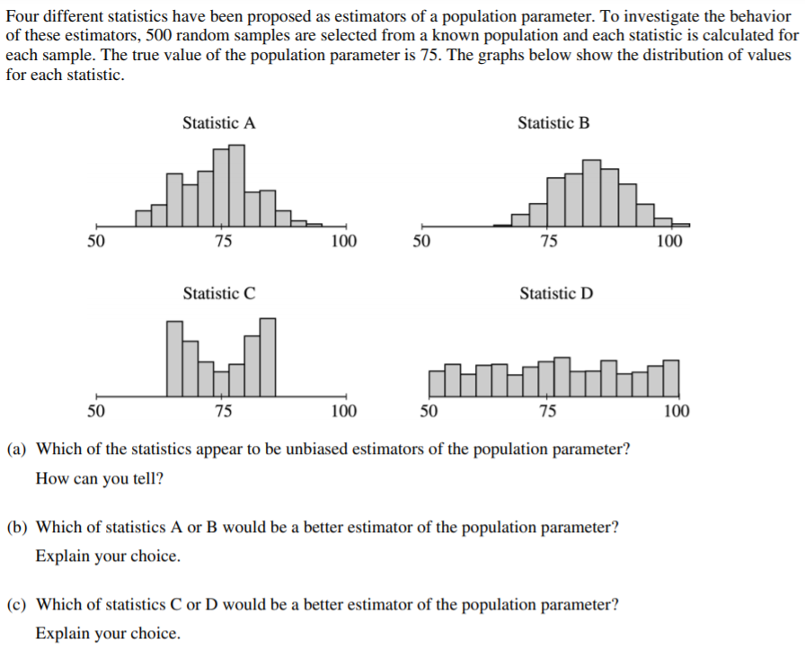6.

